PERSONAL INFORMATION | Ashfaq Ahmad
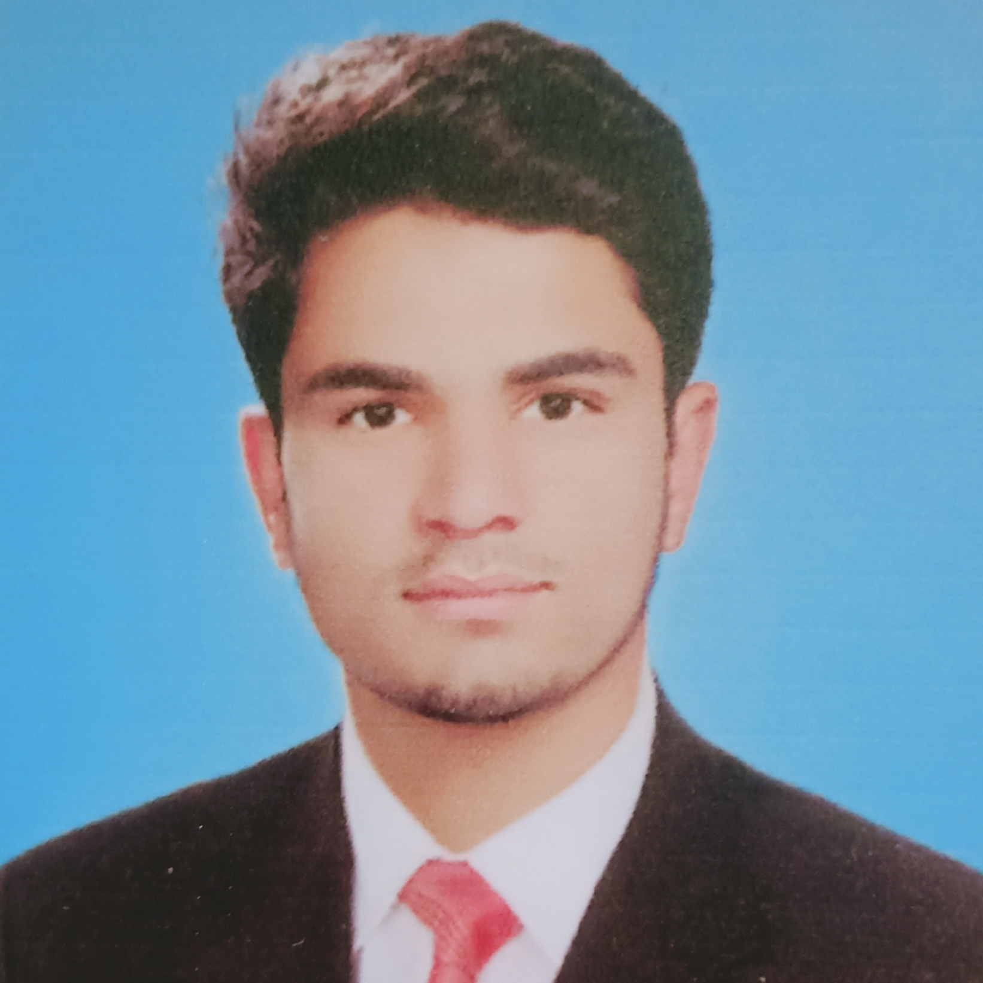

Tehsil Allai, District Battagram
 |  03449024783

19pwcse1795@uetpeshawar.edu.pk
 | Sex Male | Date of birth 03/01/2001 | Nationality Pakistani

STUDIES APPLIED FOR | BS (Computer system Engineering)

WORK EXPERIENCE

1 September 2015-january 2017  15 June 2017- 4 July 2018 | Computer Operator
1 September 2015-january 2017  15 June 2017- 4 July 2018 | UBL(United Bank Limited), Battagram (Pakistan)
1 September 2015-january 2017  15 June 2017- 4 July 2018 | - Remained as a computer operator for almost two years.
1 September 2015-january 2017  15 June 2017- 4 July 2018 | Teacher
Islamic College Battagram (Pakistan)

- Remained as a teacher of Physics and Mathematics for one year

EDUCATION AND TRAINING

23 September 2019 - Present  10 July 2016 – 20 July 2019 | BS Computer System Engineering
23 September 2019 - Present  10 July 2016 – 20 July 2019 | University of Engineering and Technology ,Peshawar
23 September 2019 - Present  10 July 2016 – 20 July 2019 | - Programming  - Probability  - Engineering Economics  - Networking  - Digital Communication system  Intermediate of Science (FSc)  Islamia College Banna Allai ,Battagram (Pakistan)

10 march 2018- 10 September 2018 Diploma of Information Technology (IT)

Muhammadia College Besham Shangla , Pakistan

PERSONAL SKILLS

Mother tongue(s) | Pashto
Other language(s) | UNDERSTANDING |  | SPEAKING |  | WRITING
Other language(s) | English | Urdu | Urdu | Pashto | English

Communication skills | - Strong Communication Acquired through my Quality Education and joining English Academies.

Computer skills | Have certain experience in Computer field  - good command of Microsoft Office™ tools  - Programming (C/C++/Assembly)  - Graphic Designing.  - Matlab

